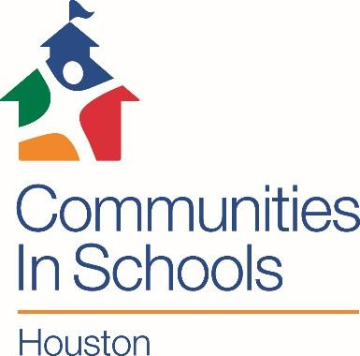

“Helping Houston students stay in school since 1979”

Dear Parent/Guardian,

**Communities In Schools of Houston (CIS)** is a non-profit organization that provides supportive services to students at **[Campus/site name].** Our mission is to surround students with a community of support, empowering them to stay in school and achieve in life.

**CIS believes** that every child needs and deserves:

1. A one-on-one relationship with a caring adult
2. A safe place to learn and grow
3. A healthy start and a healthy future
4. A marketable skill to use upon graduation
5. A chance to give back to peers and the community

We offer our students and their families services that meet real needs and provide real opportunities. **Our services include**:

|  |  |
| --- | --- |
| * Supportive Guidance & Counseling * Academic Enhancement * Cultural Enrichment Activities | * Parental & Family Involvement * Health & Human Services * Career Awareness |

If you’re interested in enrolling your child in the CIS program, please complete the attached forms. If you have any questions or need assistance with the forms, please feel free to call the number below.

Sincerely,

Jalil Cantarero

XY-Zone Student Support Specialist

(713) 361-2200 EXT: 122